Charge Ahead Colorado
Grant Application Form
Updated 7/16/15

The Regional Air Quality Council (RAQC) and Colorado Energy Office (CEO) have teamed up to provide financial support for electric vehicles (EV) and electric vehicle supply equipment (EVSE) units. The RAQC administers grant funding for EV and EVSE to fleets and entities located in the seven-county Denver Metro Area, including Adams, Arapahoe, Boulder, Broomfield, Denver, Douglas and Jefferson Counties. The RAQC also administers EV funding for the following Zip Codes in Weld County: 80504, 80513, 80601, 80603, 80621, 80623, 80642, and 80651. CEO administers grant funding for EVSE to fleets and entities located outside the seven-county Denver Metro Area. The Charge Ahead Colorado Grant Application serves applicants applying for both RAQC and CEO funding.
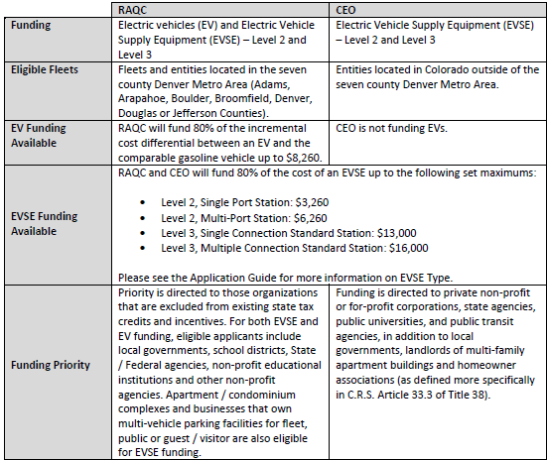
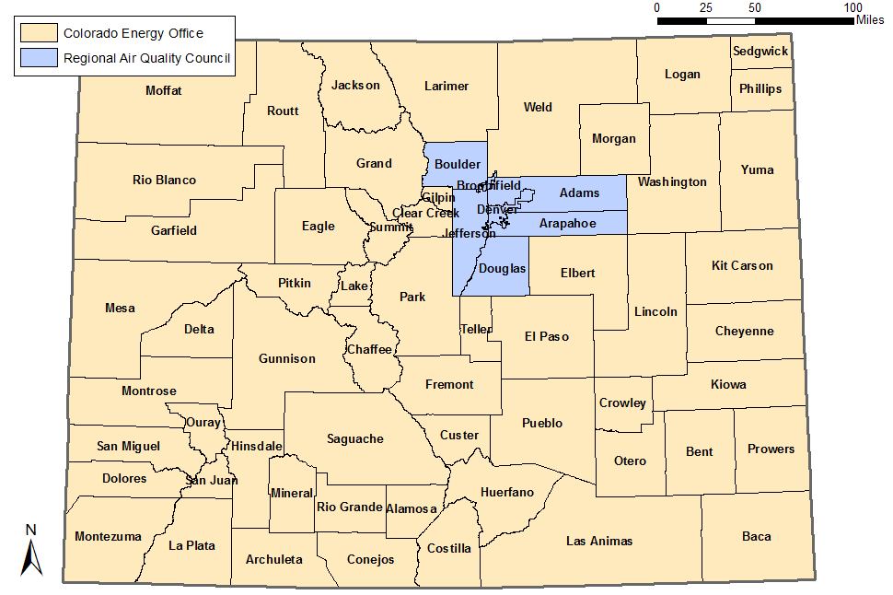
The purpose of the application is to provide the evaluation team with an understanding of the applicant’s level of planning and commitment to battery electric vehicles (BEV) and plug-in hybrid electric vehicles (PHEV) and electric vehicle supply equipment (EVSE).
Please note current incentive levels, effective March 2015. Also, please note the additional requirement that all stations be networked.

All applications must be submitted online here. Applicants must review the Charge Ahead Colorado Grant Program Application Guide prior to submitting an application. This guide is intended to lead participants through the programs funding process. The guide can be found here. In the online version, applicants must confirm that they have read the Application Guide.

Applicants are encouraged to complete proposals on this word format form, save and then transfer information to the online application. Applicants should print the completed online application and keep a copy on file. The Evaluation Committee is not responsible for any lost proposals. Please note, the online application will not allow applicants to paste tables or charts into text boxes. Please answer all questions in the narrative. If the applicant would like to additionally display information in tables or charts, please upload the documents in Section IX of the application, Additional Relevant Information.

Section I. Contact Information and Background Information

One organization must be designated as the applicant and be responsible for implementing the entirety of the submitted project.

Organization Name:
Organization Type:
Organization Address:
County:
Contact Name:
Title:
Contact Office Phone Number:
Contact Email Address:
Organization Website:
Organization DUNS Number:
Secondary Contact Name:
Secondary Contact Title:
Secondary Contact Email:
Secondary Contact Phone:

Number of Level II, Single Port EVSE Requested:
Number of Level II, Multi-port EVSE Requested:
Number of Level III, Single Connection Standard EVSE Requested:
Number of Level III, Multiple Connection Standard EVSE Requested:
Total EVSE Funding Requested (Dollar Amount)

Number of EV Requested:
Total EV Funding Requested (Dollar Amount):

Section II. Mandatory Criteria

The criteria below are based on the grant funding for these projects and are non-negotiable. Applicants must adhere to the following criteria to be eligible for project funding:

- RAQC Funding Requirements: Projects applying for RAQC funding must be located in the seven-county Denver Metropolitan Area of Adams, Arapahoe, Boulder, Broomfield, Denver, Douglas or Jefferson Counties. The RAQC also administers EV funding for the following Zip Codes in Weld County: 80504, 80513, 80601, 80603, 80621, 80623, 80642, and 80651.
- CEO Funding Requirements: Projects applying for CEO funding must be located within any other county in the State of Colorado except those that are covered by RAQC funding.
- Projects implemented prior to receiving an award AND confirmation to proceed given by the awarding agency (RAQC or CEO) are not eligible for funding. Repeat applicants are eligible for additional funding for new projects.
- RAQC funded vehicles must be registered in, and operate in, the same seven-county Denver Metropolitan Area as above.
- RAQC and CEO will allow researched estimates for EV/EVSE to be utilized in the application process. However, awards will be made based upon the amounts applicants include in their application. No awards will be adjusted upwards based on an underestimation of cost by the applicant. Therefore, it is strongly recommended that applicants perform their due diligence by contacting vendors for estimates and having them perform site visits for EVSE to ascertain solid estimates. Upon award, RAQC and CEO will meet with program applicants to discuss and review their procurement processes to ensure it meets our requirements. Do not run your bid processes prior to this meeting. RAQC and CEO must approve all bid documents before the competitive process begins. Applicants may use the 2015 State of Colorado electric vehicle bids. State bid documents may be found at: https://www.bidscolorado.com/co/portal.nsf/xpPriceAgreementsByCategory.xsp.
- EVSE must be purchased and not leased or financed to be eligible for funding.
- Manufacturers of EVs and EVSE units are not eligible to apply for grant funding.

- Vehicles may be purchased or leased. All vehicle leases must be for a minimum of 5 years unless otherwise specified by the RAQC. All leases must include an addendum to the leasing papers that the RAQC be notified of vehicle sale, vehicle destruction or modification of terms. For vehicles leased under this program, the applicant’s down payment must be equal to the funding requested from the RAQC plus the 20% required match. The RAQC will provide grant funding at the beginning of the lease in one payment. EVs must be capable of legally driving on city streets and highways.
- For EV applicants, Vehicle Miles Traveled is an important criterion. Priority will be given to applicants with the highest VMT.
- The applicant must have title ownership of the site or facility where the proposed EVSE is being installed. If not, the applicant must provide written approval for EVSE installation from the title owner of the site. We request that all HOA applicants include a formal resolution or letter of intent from the applicant’s HOA Board with their application.
- The station(s) must be kept operational and in service for a minimum of 5 years. Exceptions may be considered under circumstances of severe hardship as determined by the Evaluation Committee. The applicant must notify the awarding agency within 48 hours if a station becomes inoperable.
- If a station is sold prior to 5 years of operation, the applicant may be required to pay a pro-rated portion of the station back to the awarding agency. If a station is destroyed or otherwise disposed of, the applicant must notify the awarding agency and under certain circumstances may be required to pay a pro-rated portion of the station cost back to the awarding agency.
- The station(s) must have a dedicated parking space for EV use only.
- The applicant must agree to operate the vehicles for a minimum of 5 years in Adams, Arapahoe, Boulder, Broomfield, Denver, Douglas and/or Jefferson Counties. If a vehicle is sold prior to 5 years, the fleet will be required to pay a pro-rated portion of the vehicle cost back to the RAQC. If a vehicle is destroyed or otherwise disposed of, the fleet must notify the RAQC. Under certain circumstances, the fleet may be required to pay a pro-rated portion of the vehicle cost back to the RAQC.
- All EVSE units must be certified by Underwriters Laboratories, ETL Listed or an equivalent certification and must have a minimum one year warranty. Units must be compliant with the current version of the National Electrical Code (NEC) Article 625.
- EVSE installation must be performed by an electrician licensed to transact business in the State of Colorado and who maintains appropriate types and levels of insurance coverage.
- The applicant must apply for any required local government, utility and/or electrical permits and approvals.
- The applicant must comply with all applicable federal, state and local permitting, zoning and code requirements. Certification that all requirements have been met is required from the installing electrician.
- RAQC applicants applying for electric vehicles must comply with Buy America provisions in Title 23 United States Code, Section 313. To comply with this provision, all vehicles must have their final assembly occur in the United States. The RAQC will assist with the specific process that must be followed under this provision. Please contact the RAQC for more information.
- RAQC applicants may be subject to Davis-Bacon Act prevailing wage requirements if the project is linked to a Federal Highway based on impact or is within the existing right-of-way of a Federal Highway. To date, no RAQC project has triggered this requirement. Please contact the RAQC for more information.
- The applicant must follow independently published recommendations on the installation of EVSE in compliance with the Americans with Disabilities Act (ADA) (see http://www.vacleancities.org/wp-content/uploads/EV-Charging-ADA-Version-1.0s.pdf).
- Applicants must work with their awarding agency to share data on overall energy consumption and interval data for the operational life of the station(s). Additional information and data may be requested upon availability.
- The applicant must allow the Evaluation Committee to make all applications and bid documents public.
- The applicant must provide location(s) of funded sites with their awarding agency and the DOE’s Alternative Fuels Data Center.
- The applicant must provide a minimum of 20% matching funds or cash match for each EV and/or EVSE. These matching funds cannot be direct or indirect federal funds. For electric vehicles, please note that the RAQC is paying 80% of the incremental cost between an EV and its comparable conventionally fueled vehicle. Only the remaining 20% of this incremental cost (i.e. not the full base vehicle cost) can be used as match for vehicle requests. Any tax an applicant pays may not be used as match. For any questions on EV and EVSE match, please contact the RAQC. For CEO funding, if a location is especially advantageous for support of the electric vehicle market but other revenues are not and will not foreseeably be available to defray the costs of installation, CEO may grant the full cost of installation.
- In order to be reimbursed, all claimed eligible costs and final invoicing must be provided in a legible format and may be required on a form provided by the RAQC or CEO. Backup original invoicing will be required at the time of submittal. If documents are illegible, confusing or incorrect in any manner, the project will not be funded. It is the responsibility of the applicant to ensure documents are clear.

As the project applicant, I hereby certify and agree to the aforementioned Mandatory Criteria.

_________________________________________________________________________
Sign and Print Name

Section III. Scope and Project Justification

- Please provide a brief summary of the project you are submitting. Please indicate your entity’s top priorities for funding if grant funds are limited due to demand.

- Please describe in specific detail how your project addresses the five program goals listed in Section I of the Application Guide. Applicants should consider the 19 criteria in Section III of the Application Guide when answering this question.
- Please describe major phases of the project and the estimated completion date of each phase.

Section IV. Planning Criteria

Organizations applying for funding need to demonstrate to the Evaluation Committee their ability to sustain the funds invested in this EV/EVSE project. The Evaluation Committee requires applicants to address planning areas below.

All applicants must answer the following questions:

- Does your organization have specific or general planning documents related to EV or EVSE? For example, fleet implementation plans, Smart Charging plans, or sustainability plans. If yes, please attach the documents to your application. If no, are you interested in learning more about developing EV/EVSE planning documents? Refuel Colorado can provide technical assistance on this matter.

Is your organization partnering with other entities to complete this project? If yes, please provide a list of partners.

- Please describe any renewable energy or energy efficiency assets that may reduce the overall environmental impact of your EVSE facility and/or charging of your EV.

- Has your organization secured the matching funds for this project? Please describe the source and amounts secured for this application.
Applicants applying for EVSE must answer the following additional questions:

- Has your organization received any interest from stakeholders/employees/owners/lessees that own EVs for EVSE installations at your location? Please describe.

- Please provide the address of the EVSE location(s).

Location Name | Address | City | State | Zip

- Please provide a description of the site location including nearby amenities (i.e. public facilities, museums, parks, etc.) and hours of access.

- Will all the EVSE units be open to the public? If not all units, how many?

- How will the parking queue be managed? (i.e., will there be a time limit for charging, will there be an attendant that monitors the queue?)

- Is your organization planning to charge parking/charging fees for users in the next three years? Please explain.

- If yes, how will parking transactions be handled?

- Beyond charging, what functionality does the applicant expect the charger to have (i.e. obtain data such as usage, time of day, etc.)? Please explain.

- How many vehicles can be charged by each EVSE unit? To what extent does the applicant expect that these stations can be upgraded in the future to charge more vehicles?

- In Section I. of the Application, you specified the level, number and type of connection points for which you are requesting funding. Why has your organization chosen this specific EVSE configuration and how often do you anticipate the EVSE(s) will be used?

- Applicants must keep all EVSE operational for a minimum of five years. Please describe how your organization plans to maintain the EVSE. Please attach any maintenance plans your organization has for the EVSE.

- How does your organization anticipate handling any peak demand charges incurred as a result of the addition of EVSE at your facility? Have any plans been put in place to avoid peak demand charges? Please explain.

- For Level III EVSE, please mark which connection standards you anticipate your EVSE will have – SAE J1772 Combo Standard Only, CHAdeMO Standard Only, or Both SAE J1772 Combo and CHAdeMO Standards.

Applicants applying for EV must answer the following additional questions:

- Do you plan to lease or purchase the EV(s)?
- Does your fleet utilize vehicle telematics or track fleet mileage in another manner? Please indicate what method is used. If a telematics system is not used, is your fleet interested in this technology?

- Where do you plan to charge the EV(s)?
- How many miles do you anticipate the EV(s) will travel annually?
- For PHEV(s), please list the estimated percentage of miles using electricity alone.

- Is your fleet retiring or replacing any conventionally fueled vehicles upon purchase of the electric vehicles? If yes, provide information on the vehicles you anticipate you will retire or replace.

Vehicle Type | Engine Make | Engine Year | Engine Model | Engine Size (HP) | Fuel Type | Fuel Used (gal/year) | Annual Miles | Annual Idling Hours

Section V. Funding Request
For EVs, please indicate the make, model, type and quantity of all vehicles that you seek to receive grant funding for. Please provide researched estimates for vehicle cost. The RAQC will award 80% of the incremental cost between an EV and its comparable conventionally fueled vehicle up to $8,260. No awards will be adjusted upwards based on an underestimation of cost by the applicant. Therefore, it is strongly recommended that applicants perform their due diligence by contacting vendors for estimates. Upon award, RAQC will meet with program applicants to discuss and review their procurement processes to ensure it meets RAQC requirements. Do not run your bid processes prior to this meeting. RAQC must approve all bid documents before the competitive process begins.

Quantity | Vehicle Use* | EV Model Year | EV Make | EV Model | EV Cost | Gas/Diesel Fueled  Vehicle Model Year | Gas/Diesel Fueled  Vehicle Make | Gas/Diesel Fueled  Vehicle Model | Gas/Diesel Fueled  Vehicle Cost | Incremental Cost per Vehicle
* Please describe how the vehicle(s) will be used (i.e. specific fleet applications such as parking enforcement, general use to drive to meetings, law enforcement/security, etc.).

For EVSE units, please indicate the types of EVSE that will be publicly accessible and not publicly accessible with researched costs below. Both RAQC and CEO will award 80% of EVSE equipment, labor, construction and permitting cost up to the amounts listed in the Application Guide. The RAQC will also award 80% of the additional reporting costs* up to the amounts listed in the Application Guide. No awards will be adjusted upwards based on an underestimation of cost by the applicant. Therefore, it is strongly recommended that applicants perform their due diligence by contacting vendors for estimates. Upon award, RAQC and CEO will meet with program applicants to discuss and review their procurement processes to ensure it meets RAQC and CEO requirements. Do not run your bid processes prior to this meeting. RAQC and CEO must approve all bid documents before the competitive process begins.

Location Name | Type (Level II or III) | Number of Vehicles that This Unit Can Charge at Once | EVSE Equipment Cost per Unit | EVSE Labor Cost per Unit | EVSE Construction Cost per Unit | EVSE Permitting Cost per Unit | EVSE Additional Reporting Cost per Unit* | Expected Date of Purchase | Proposed Installation Date | Publically Accessible (Yes or No)
*Additional Reporting Costs may include subscription fees, data plans, etc. Please note that projects are prioritized in part by the quality of the charging station to be installed, with emphasis on reporting data provided.

Section VI. Federal Certifications

All applicants must agree to the following Federal Certifications and Assurances. The online application will ask applicants to provide e-signatures and upload a current W-9.

- Certification Regarding Lobbying

- Certification Regarding Debarment, Suspension and Other Responsibility Matters
- W-9: Request for Taxpayer Identification Number and Certification

Section VII. Reporting Requirements

Within six months of installation, RAQC and CEO will send out a form requesting information on EV and/or EVSE usage (i.e. time of use, duration of use, # of customers, mileage, kWh used etc.). For EVSE, RAQC and CEO require read-only access to the charger network information. This is effective July 2015. The grantee will be asked to report data at six month intervals (in January and June) for a minimum of three years. The grantee will be expected to provide information that is readily available.

As the project applicant, I hereby certify and agree to the aforementioned Reporting Requirements.

_________________________________________________________________________
Sign and Print Name

Section VIII. Final Documentation Required

Upon completion of the installation and/or vehicle purchase, the following documentation is required for RAQC and CEO to reimburse for eligible costs on all projects:

- Final Report.
- Summary Invoice/Reimbursement Request.
- Legible copies of all sales/invoices show the purchase price and amount paid by the applicant for the EV/EVSE, number of units purchase and serial numbers from the units and VINs from the vehicles.
- Copies of canceled checks or credit card statements as proof of payment for all costs.
- Digital photograph(s) of the completed unit(s) and/or new vehicles.

Applicants must also submit the following for all EVSE projects:

- A copy of the installer’s written certification that the unit(s) have been installed, in working order and operating in accordance with local, state and federal codes.
- Copies of all required permits.
- Date(s) of installation, installation completion and when the unit(s) is operational.

Section IX. Additional Relevant Information

- How did you hear about the Charge Ahead Colorado program?

- Is there any additional relevant information that will assist the Evaluation Committee in understanding the proposed project?

- Are there any additional documents that help support your application? Please attach any additional relevant information. If you are attaching documents, please include a description of the documents attached.

